The ZWO unit has overlapping lever slots (~60° overlap) similar to the Pierro-Astro. This helps to make initial orientation of the ADC body in the imaging train less critical than some other ADCs, as it allows plenty of travel to set the levers with reference to the horizon. This is one reason why the adjustment scale is a rotating ring--- you rotate the ring so it's locking screw is horizontal, then the levers can be adjusted referenced to that locking screw.

In using this ADC, one sets the white nylon screw on the rotating scale ring level to the horizon to act as the datum point from which to adjust the spread of the levers to either increase or decrease correction strength. This is much easier to do straight-through (no diagonal) with either refractors or Cassegrains. If a diagonal is used, as you probably know depending upon how the diagonal is tilted the horizon will appear tilted in the scope (it's easier to use the diagonal pointed straight up). This has to be considered when using a diagonal. This is also true for Newtonians as explained here:  
[http://www.skyinspec...-corrector--adc](http://www.skyinspector.co.uk/atm-dispersion-corrector--adc)

Use of a diagonal also flips the correction polarity produced by the ADC. Example: if it works properly straight-through with an SCT and the levers are pointing to the left; if you then use a diagonal you'll find that you have to rotate the ADC so that the levers point to the right.

For those of us using any kind of equatorial mount, the ADC needs adjusting in both degree of correction and angle (to keep the correction "parallel" to the horizon).

With everything else at high resolution, results are very, very seeing-subjective. But in average-to-good seeing with, say, Jupiter at +10 declination, I found myself making both adjustments about every 30-40 minutes or so during the early part of the rising phase. This does indeed slow as the target reaches higher elevation. You can probably get away with no adjustments at all once the target reaches an elevation of 55 degrees or thereabouts.  
  
When the seeing is poorer, you can't really see a difference between 'spot on' adjustment and a little bit off, so the regime of adjusting is a little less rigorous.

Darryl, you are correct in your assumptions of when it's prudent to adjust the levers relatively frequently (during ascent and decent) and when it's OK to go perhaps as much as an hour or so when the planets are a couple of hours on either side of culmination.

Grant has given you solid info. :waytogo:  It's worth noting though that if properly set up with some pre-planning, in most cases the ZWO's overlapping slot travel and rotating adjustment scale allow using it without having to stop and rotate it in the imaging train even in long imaging sessions.

As for the resetting the horizontal datum point marked by the rotating adjustment scale's white plastic screw (Let's call it the datum screw): With the ZWO ADC's rotating scale you can reset that datum screw at any time you wish, and since it's easy to grab both levers simultaneously with your thumb and/or finger tips it's easy to reposition them so that their midpoint falls at the new datum screw setting--- this can all be done in seconds once you get used to it, and near culmination you don't really need to worry about changing the spread amount of the levers unless you're really picky--- just recentering them to the datum screw should be good enough when near culmination. With experience you'll get a feel for getting a good guesstimate of tweaking the lever spread adjustment if the attitude has noticeably changed. If using a color cam with the latest FireCapture, spending a few minutes using the new "ADC Tuning" toolbar action will help in fine tuning the correction.

Eventually you'll have enough experience where this will all be second nature. I don't even always set the datum screw with my ADC--- I just know where the levers should go.

You can practice basic ADC adjustment while holding just the ADC in your hands in the comfort of your home! First, I should mention that when used with a Cassegrain (SCT) or refractor straight through (no diagonal) the ZWO is made so that it produces the proper opposing dispersion polarity with the levers pointing to the left. (Note: if used after a diagonal, the ADC needs to be rotated 180° so that the levers point to the right for proper correction.) Apologies to the Newtonian users out there for now--- I'm sure we'll eventually address their ADC quirks in time on this forum!    
1.) So for this example with the levers pointing to the left, hold the ADC up in the air and pretend you are pointing the ADC where a planet would be culminating on the meridian. You should also have the side of the ADC where the lever slots overlap also roughly pointing to the left--- this allows enough lever adjustment travel for most, if not all of the planet's path across the sky through the night _without_ having to rotate/reposition the ADC in the focuser.  
2.)  Now swing the ADC down towards the point where the planet would be low in the sky, maybe ~20°, shortly after rising. Position the rotating ring scale/datum screw to the left to reference the horizon. Since you are supposed to be pointing at a low planet, the dispersion will be strong and will require the prism levers to be spread apart by most of their slot travel--- the upper lever will be the scope-side lever, lower lever the output side lever. The levers spread width is of course to be centered on the datum screw.  
3.) Slowly swing the ADC back to the meridian position while adjusting the levers closer together as the necessary correction amount would lessen as you approach the meridian. Adjust the scale ring datum screw as needed.  
4.) Now swing the ADC past the meridian and towards the horizon where our imaginary planet would eventually set, all the while slowly widening the spread of the levers again as in step #2, and taking moments to reset the scale/datum screw to the horizon.  
5.) Rinse and repeat, then take a beer break.  :grin:

Practicing like this should help familiarize yourself with ADC use, and probably help in designing your imaging train and in formulating new questions or ideas to share with us here on CN. Not to mention creating yet another reason for your significant other to worry about you. :lol:

ADCs are certainly something that require tweaking. Since dispersion occurs along a line perpendicular to the horizon, the ADC has to be rotated to match that. With a Risley prism ADC, when you adjust the unit the planet will move up/down in the FOV far enough to move the planet off of the typical camera's sensor. For this reason I prefer adjusting the ADC visually using an eyepiece set to be parfocal with the camera, especially with a monochrome camera--- it is possible to adjust the correction well enough from the live view with a color camera as long as the seeing is reasonable. The amount of correction varies with the light path length after an ADC, so if your using an eyepiece that has a noticeably different focal point than the camera, you are not setting the ADC correction accurately. Of course fine tuning the focus once the camera is back in place is necessary, but since the refocus requirement is fairly close to that of the parfocal eyepiece, the ADC correction setting will still be OK.

Despite the required horizontal orientation and prism setting tweaking, in practice I seldom tweak these adjustment more than every half hour. Being just a bit out of adjustment is still much better than no ADC at all. I know Damian Peach has also mentioned only worrying about ADC settings every 30 to 60 minutes depending on the path through the sky of the target planet. Maybe in years to come there will be motorized ADCs that can be set up to self adjust, but for now they are manually adjusted, but one gets used to it and it's not really a big hassle with experience. It eventually becomes second nature.

With an equatorially mounted scope the ADC horizontal alignment does need to be adjusted now and then, as of course do the ADC levers to adjust the amount of dispersion correction itself. But the majority of my adjustments are in the 30 minute or longer interval range--- only very rarely do I adjust as quickly as 20 minute intervals (and even then I admit that may be overkill). Only with experience with an ADC over time will you settle on adjustment intervals that work well for you. Tolerance in horizontal alignment is pretty loose which is why manufacturers don't put a precision reference line or a bubble level on the ADC--- eyeballing it is good enough. In most cases a good ADC dispersion setting should work well enough for maybe a 5° change in altitude before the error is noticeable even in excellent seeing.

While taking measurements of your dispersion at different altitudes is a good way to help set up the ADC quickly, the dispersion level will vary somewhat with weather conditions, especially humidity. So only use those figures as a guide, as you still may find yourself tweaking the settings a bit differently at times. I've noticed a difference in setting between fair vs. great transparency. Also keep in mind that varying projection distance from the ADC to the camera or eyepiece changes the degree of correction.

After buying ADC, I faced the problem of setting the correct angle between the prisms for a given altitude. Relatively simple solution occurred to me when focusing with Bahtinov mask. The first image shows the light from Spica after passing through the mask oriented horizontally and the L filter. Well are displayed the second order diffraction spectra. The blue color is higher above the horizon than the red one. The second picture shows correction made by ADC. It seems that the blue end is slightly overcorrected here. Dispersion of air has a slightly different wavelength dependence than fused silica.  
For a given optical train is now sufficient to perform a half-dozen measurements, and later just interpolate ADC angles for different altitudes.

Attached Thumbnails

* [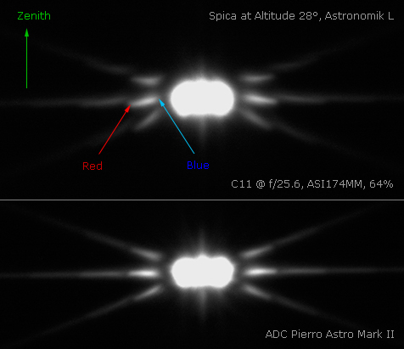](http://www.cloudynights.com/uploads/monthly_06_2015/post-93978-0-90612400-1433611498.jpg)

A few days ago it came to my attention that Darryl's (Kokatha man) ADC is built with the wedge prisms mounted in a reversed manner to those in the ZWO ADC I was given to test back in early November. Thinking that it could possibly be my ADC that was the outlier as mine was a test unit, I asked a couple of others to check theirs--- Sean Walker's is like Darryl's, while Paul Maxon's is built like mine. So there are examples of both out there.

Either way of building the ADC is 100% correct--- both work equally well. But between them, the initial setup in a given scope is different: In several previous posts I've made describing how to use the ZWO ADC, I described that with an inverting scope that the prism levers and white nylon scale ring screw (a.k.a. datum screw) needed to be on the left side--- initially thinking that all were made like mine. However with the prisms mounted as in Darryl's, the prism levers and datum screw need to be mounted to the right in an inverting scope. The best way to describe this is that some are built left-handed, and others are right-hand ADCs. They simply have different dispersion correction polarity which is fixed by mounting the right-hand ADC to the scope with their bodies rotated 180° vs. the left-hand ones.

In notifying Sam Wen of ZWO about this, he thinks this occurred because of multiple staff members assembling the units. While they are working to standardize the assembly procedure from now on--- and I'm not sure which way will be the standard--- it's always possible that some opposite polarity ADCs will be produced. For background, I also own a Pierro-Astro which is right-handed, and have tested an ASH ADC which is left-handed. I do not know if the direction of those other brands is standardized though, and it's always possible that there are examples of both with those models too.

Attached is a ZWO ADC polarity test image that you can test your ADC's correction polarity with. The answer will determine if your levers should be pointed to the left or right when used in an inverting telescope--- please click on the thumbnail for the full size image.

In the center you'll see a large white disk with a small black center with subtle color fringes simulating spectral dispersion. To either side of the image there are also grey silhouettes of left-hand and right-hand ADCs shown with their levers spread apart and with the ring scale datum screw between them representing a proper horizontal reference.  
Holding your ZWO ADC at arm's length from your monitor and while looking through the ADC with one eye, view the dispersed central disk and spread the levers to try to cancel out the color fringing. You should find that you'll correct the color fringes only with your ADC levers to one side and not the other, roughly matching either of the silhouettes.

So now you should know if your ADC is left or right-handed in a inverting scope. But what about use with a diagonal, which corrects the image vertically? First of all, using a diagonal complicates things so I don't recommend it. But if you have to, you'll find that an ADC with left-hand prism levers will need to be used with the levers to the right when used after a diagonal (the eye/camera end). The reverse is true with a right-hand ADC.

Comments and questions certainly welcomed.

Attached Thumbnails

* [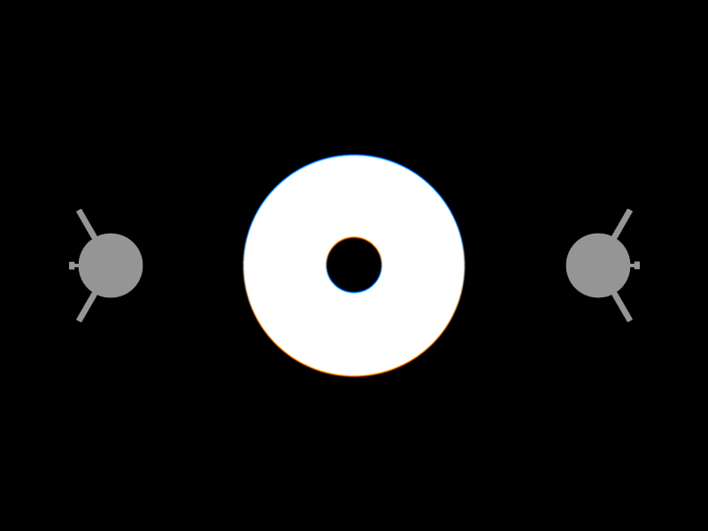](http://www.cloudynights.com/uploads/monthly_01_2016/post-42840-0-28528800-1453732881.jpg)

Thanks John for the additional info.

Some of the confusion about left vs right handed may also be due to the fact that some these units can be used front to back or back to front.  These devices have T2 connections on both ends.   When this is done the left handed or right handed property is reversed.  It will still work either way.

In general if increasing the correction makes dispersion worse, then it needs to be rotated 180 degrees.

Bifocals may make it difficult to assess correction in a monitor test.  Also blue does not show well on some monitors.  Here is an additional graphic one can employ.  It is simply a circle 1 pixel in breadth with green offset 1 pixel upwards from red, no blue layer.  IIRC increasing correction moves the image downwards when in the proper orientation.   If not rotate unit 180 degrees.  Depending on the image orientation this rotation may also be required depending on the scope and the image projection used.

[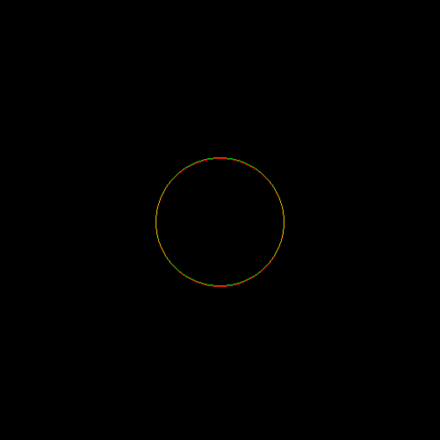](http://www.cloudynights.com/uploads/monthly_01_2016/post-17228-0-72088400-1453778827.png)

It may help some to display this image full-screen.  Also some LCD monitors may bias the image slightly.

Glenn