WHICH STARS ARE BEST TO USE FOR POLAR ALIGNING?
For best results, choose a bright alignment star that is near the Meridian, preferably close to the celestial equator. Try to avoid stars that are close to the west/east horizon or directly overhead; they can be more difficult to center using the mount’s altitude and azimuth controls. Also, stars too near the celestial pole are less accurate than those further away.

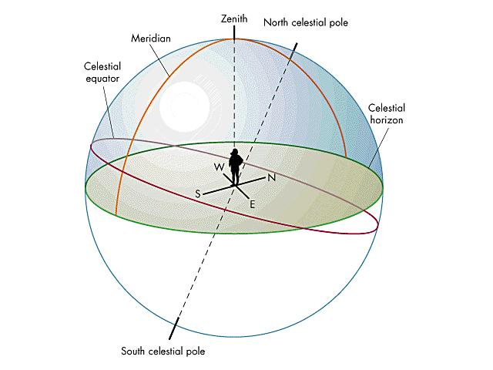
Meridian: A meridian is the great circle passing through the celestial poles, the zenith, and the nadir of a particular location. Consequently, it contains also the horizon's north and south points, and it is perpendicular to the celestial equator and to the celestial horizon. A celestial meridian matches the projection, onto the celestial sphere, of a terrestrial meridian. Hence there are an infinite number of meridians.

WILL I LOSE MY ALIGNMENT AFTER I POLAR ALIGN?
No. The mount will retain its alignment, but some amount of accuracy may be compromised depending on how much the mount was moved during polar alignment. Although the telescope’s tracking may be very good, pointing accuracy may need to be improved, especially if you are trying to locate small objects on a CCD chip.
HOW DO I POLAR ALIGN MY TELESCOPE USING ALL-STAR POLAR ALIGNMENT?
- Align the telescope with the sky using the Two-Star Alignment method.
- Align to at least one calibration star on the opposite side of the meridian.
- Select a suitable bright star from the NexStar hand control’s database. Slew the telescope to the star.
- Press the Align button. Select “Polar Align” then “Align Mount” from the list.
- The telescope will then re-slew to the alignment star and ask you to center it in the eyepiece in order to "sync" on the star.
- The telescope will slew to the position that the star should be if it were accurately polar-aligned.
- Use the mount’s altitude and azimuth adjustments to center the star in the eyepiece.
- Press the Align button.
- If necessary, update the telescope’s star alignment.

